Long after our clothing has disintegrated to dust, the buttons which allowed it to function remain—whether snipped from that clothing for frugal reuse or to be kept as things of true beauty. Whether worn on a work shirt, military uniform or fancy dress, a single button may have been touched a thousand times by hands no longer here. Buttons hold our clothing and hold our soul. Their preservation tells our story. Joy Journeay, NBS President

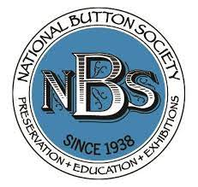
For the Media
Now celebrating over 80 years as a society, with membership on four continents, the National Button Society (NBS) is actively represented by state and local button clubs across the US and in sixteen countries.
NBS members engage in a fascinating journey of discovery, involving history, art and fashion, that encompasses centuries of usage of both clothing button buttons and related items such as buckles and studs. With a passion for studying, displaying, and trading buttons, members may create art or jewelry featuring unharmed clothing buttons.
NBS promotes educational research and exhibitions, the publication and dissemination of information, and the preservation of the button’s aesthetic and historic significance - all for current enjoyment and for future generations.
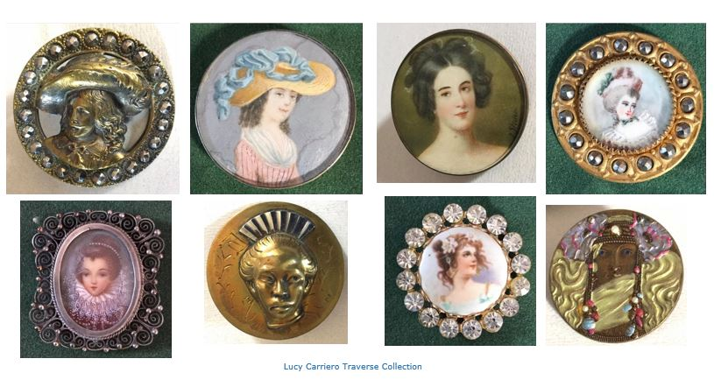

History of Button Collecting
Button collecting was first recognized as an organized hobby through the founding of the National Button Society in 1938 after a collector's appearance on the radio show, "Hobby Lobby." The regional show sparked a keen interest in this unusual hobby, which just about anyone could afford during those lean years, and it sparked a national search of attics, basements and sewing rooms for buttons.
The first button show was held in Chicago in 1939. Many state and local button clubs were established during the 1940s, and soon sponsored their own button shows, a tradition that continues today.

FAQs for a collector
Q: What do you look for in a button?
A: The historical significance; the subject matter of the button; condition; the material from which it is made, intricacy of design and manufacture… does it fit with other categories; does it speak to one’s heart … Yes, the list is long.

Q: Where do you find your buttons?
A: There are several button shows each year. Sometimes a local antique shop will have buttons; estate and garage sales; there are online sales and auctions; even telling friends that you collect – they often have their grandmother's button box tucked away.

Q. How do you display or keep your buttons?
A: NBS recommends the standardized size 9" X12" mat boards with mounted buttons grouped by materials, shapes, pictorial elements, construction methods. There are dozens of different categories found in the Official NBS Classification & Competition Guidelines: The NBS Blue Book. Also, collectors are innovative with display and storage ideas hanging lovely “button pictures” on their walls, storing buttons in wooden printer trays and other handy items, all the while paying attention to what is needed to preserve those buttons. For example, buttons need to breathe. Old celluloid buttons and polymers can corrode nearby metals and paper, so no closed jars or plastic bags, please!
Q: What is your favorite?
A: Every collector will have a favorite or more than one! Story buttons; china buttons; pearls (shell); black glass; Jacksonians; lacy glass; colorful buttons from the Colt (think “guns”) Manufacturing Company; French couture buttons; or just pretty buttons… you get the picture.

Q: What are buttons worth?
A: Prices range from pennies to many hundreds of dollars.
Q: What advice would you give to a new collector?
A: Join the National Button Society and a state and/or local button club. There are button clubs in 39 of 50 states as well as several clubs in Canada, Europe, Japan, Australia, etc.

Leadership and Contacts:
NBS President and 2023 Show Chair: Joy Journeay of Alaska
Joy Journeay's first love is art - she has a BFA in stone lithography. Creativity and buttons have been hobbies and, since retirement, fill much of her time. Researching a button's story provides hours of satisfying discovery. Joy is leading NBS expansion into online events, connecting button enthusists across the miles and bringing together novice and experienced collectors. Each week members can join in a Button Room discussion, as well as attend monthly educational presentations.
NBS Vice President: Linda Beatty
Linda Beatty has three loves: buttons, politics and history. As a child, she idled away hours in her father’s laundry button box, from which broken or missing buttons were replaced without charge. In 2000 Linda attended a button club meeting. The love affair began with our button hobby that includes research into history and politics. Linda started the Button Seekers Club in Iowa and has served in various positions with the Iowa State Button Society and on the board of the National Button Society.

Logo and Policies
The name National Button Society is a registered trademark of the National Button Society. Specific regulations regarding the use of the Logo are listed here — https://members.nationalbuttonsociety.org/sys/website/system-pages/?pageId=1863436 . Permission must be applied for and obtained to use any of the images on the National Button Society and Button Country websites.

Contact: Susan W. Smith, Publicity@nationalbuttonsociety.org
©NBS, 2022 For the Media
Author, SW Smith, Ottawa, ON. Canada
Revised November 2022

